Geometric & Inertial Properties of Areas Enclosed by Irregular Boundaries
Husain Jubran Al-Gahtani
Associate Professor, Civil Engineering Dept., KFUPM, Dhahran 31261 Saudi Arabia
Abstract
The paper presents a simple procedure for computing various geometric and inertial properties of two-dimensional irregular shapes. The domain integrals representing the properties are transformed into line integrals using Green's theorem. The line integrals are computed by employing linear and quadratic elements to represent the coordinates over the boundary. The procedure produces exact and symbolic results for shapes enclosed by boundaries that can be represented by 1st or 2nd order polynomials. Several examples are presented to illustrate the capability of the proposed method.

Keywords: Inertial Properties; Green's theorem; Mathematica

- Introduction
The geometric properties of shapes such as areas and centroids as well as their inertial properties such as first and second moment of areas about specified axes are essential for many problems in structural mechanics and dynamics. These properties can be computed easily for simple shapes. For shapes with curved boundaries defined by parametric functions, the properties can be obtained by integration. However, the procedure becomes tedious for shapes enclosed by complicated boundaries. This difficulty is often overcome experimentally by the use of electronic instruments such as the torsional pendulum [1] or numerically [2,3,4]. Most of the available numerical techniques are based on the assumption of piece-wise straight boundaries. Wilson and Farrior [2] presented an algorithm for computing inertial properties for shapes bounded by straight lines and arcs. Tian-Yuan [3] employed cubic splines for carrying out the line integration but no exact formulas were presented. Miles and Tough [4] assumed cubic splines expressed using local coordinates and obtained formulas in terms of the of the local coordinates and the gradients of the boundary curve at the boundary nodes. However, the formulas are involved. The objective of this paper is to present a general, yet simple, procedure for computing various geometric and inertial properties of irregular shapes. The method is based on the use of Green's theorem and employing linear and quadratic elements to represent the coordinates over the boundary. The procedure produces exact and symbolic formulas for shapes enclosed by boundaries that can be represented by 1st or 2nd order polynomials. The procedure can be extended easily for boundary curves represented by higher order elements.

- Integrals for Computing Geometric and Inertial Properties
Consider a general two-dimensional domain in the x-y plane enclosed by a piece-wise continuous boundary as shown in Figure 1. Then, various geometric and inertial properties of the domain are obtained by computing the following integrals:
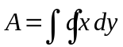; 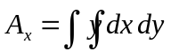; 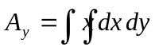; 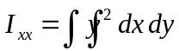;
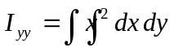; 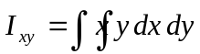; 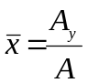; 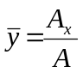 (1)
where A is area, 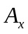is the moment of area about x-axis, 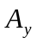 is the moment of area about y-axis, 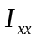is the moment of inertia about x-axis, 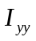is the moment of inertia about y-axis, 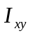 is the product of inertia and & are the x and y coordinates of the geometric center or centroid of the given domain. Each one of the above integrals can be written in one of the following forms:
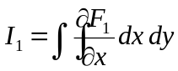, 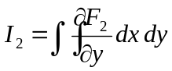, or 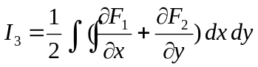 (2)
where F₁ is x,x y, x²/2, x y², x³/3 and x²/2 y for A, ,, , and respectively. F₂ can be obtained in the same manner. Putting the integrals of equation (1) in each one of the three forms given by (2) and using the well known Green’s theorem for transforming domain to boundary integrals, the following equations are obtained for each case:
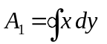 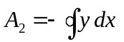 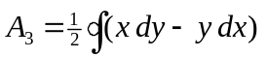 (3)
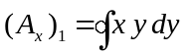 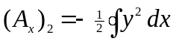 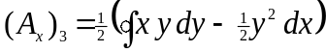 (4)
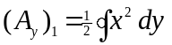 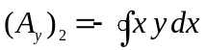 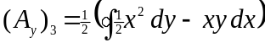 (5)
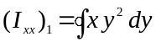 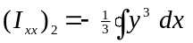 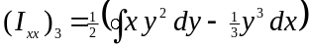 (6)
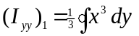 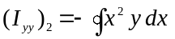 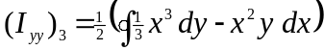 (7)
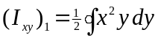 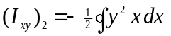 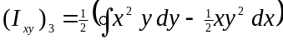 (8),
where the line integration over the boundary is counterclockwise for the exterior boundary and clockwise for the interior boundary as shown in Figure 1.

- Boundary Approximation
Our objective here is to compute the integrals defined above for a general boundary curve. As a first step, let us represent the boundary by N number of nodes as shown in Figure 2. Consider the j^{th} segment connecting the nodes x_{j} and x_{j+1} and let us interpolate the x-coordinate of the boundary linearly over that segment using a local coordinate z, i.e.
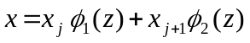 x_{j} < x < x_{j+1} where 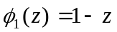 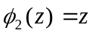 (9)
So that z = 0 corresponds to x_{j}, while z =1 corresponds to x_{j+1}. Similarly, for the y-coordinate we have:
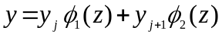 y_{j} < y < y_{j+1} where (10)
We also need the differential quantities dx and dy which can be obtained by differentiating equations (9) and 10, respectively:
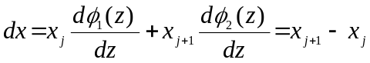 (11)
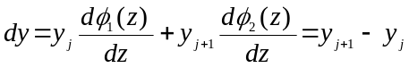 (12)
Let us consider the area integrals given in equation (3). The first integral can be computed by summing the sub-integrals over the N segments, i.e.
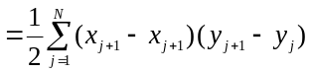
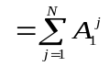 (13)
where 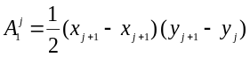is the contribution of the jth segment. If the procedure is repeated for the second and third forms, we get:
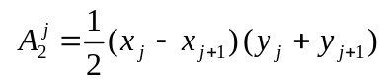 (14)
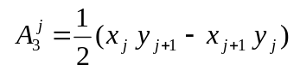 (15)
Note that although different results are obtained for each form, all should produce the same final result after summing all sub-integrals over the N segments. Repeating the procedure for other properties, we can get formulas for all cases as given in Table 1. The computation of all integrals was performed using the symbolic package Mathematica [5]. It should be noted that the generated formulas yield exact and symbolic results for domains enclosed by piece wise straight segments.
As a more refined approximation, let us assume a 2nd order polynomial interpolation over each boundary segment, i.e. equation (9) is replaced by:
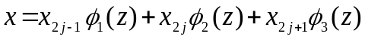 (16)
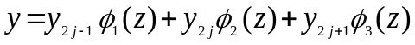 (17)
where 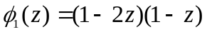 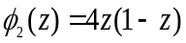 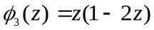
Differential quantities dx and dy can be obtained by differentiating equations (16) and (17) to get:
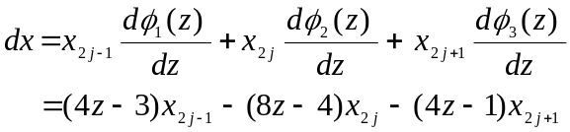 (18)
(19)
Carrying out integrations over each segment for each one of the integrals given in (1) to (8), we get element formulas as shown in Table 2. The above procedure can be applied to higher interpolation orders, however, the resulted formulas become lengthy and unpractical to use. Formulas in Table 1 and 2 can be used to compute the required property for any given section whose boundary is described by x-y coordinates. The following three examples illustrate the usefulness of the generated formulas.
- Numerical Examples
4.1 Regular Polygon
Assume that the polygon is centered at origin so that the vertices of the polygon are located at a distance R from the origin as shown in Figure 3. The vertices of the polygon are used to represent the boundary. Assuming that the first vertex is lying on the positive x-axis, the x and y coordinates of the vertices are given by:
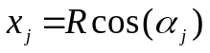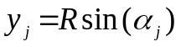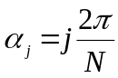
where N is the number of vertices (or sides) of the polygon. Due to the symmetry of the shape, the only non-zero properties are the area and moment of inertia about x and y. Using the formula based on linear segments (Table 1) and summing over all sides, we can get exact symbolic results for the area and moment of inertia of the polygon for N =3,4, ...etc. The results for N up to 12 are given in Table 3. These results suggest that the area and moment of inertias Ixx & Iyy, for a regular polygon with N sides, are given by:
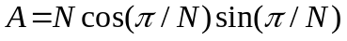
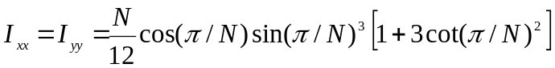
3.2 A circular section with a semicircular groove
The section is shown in Figure 4. The boundary can be characterized by the following equation:
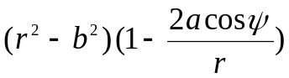
The boundary is represented by quadratic elements using three different values of N = 6, 12 and 18 in order to check convergence of the results. The non-zero properties are A, 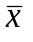, I_{xx} and I_{yy}. The numerical results along with the exact results for these properties are given in Table 4.

3.3 A turbine blade
The geometry of the blade is shown in Figure 5. The exterior and interior boundaries of the section are modeled by linear elements with N = 12, 15 and 20. The results for various section properties are given in Table 5.

5. Conclusion
A simple yet accurate method is presented for the computation of geometric and inertial properties of a general two-dimensional area. The proposed method yields exact formulas in terms of boundary coordinates for areas bounded by straight segments and curves represented by 2nd order polynomials. The generated formulas were tested through three examples and they have proven to be accurate and easy to be implemented in a symbolic Mathematica code.

Acknowledgement
The author would like to express his appreciation for King Fahd University of Pertoleum & Minerals (KFUPM) for their support.

References
Miles, R.G. and Tough, J.G., 1983, " A method for the Computation of Inertial Properties for General areas", Computer-aided Design, Vol. 15(4), pp.196-198.
Ringegni, P.L. and Actis, M. D., "Pedulum Measurement", Vol. 29(1), pp. 63- 75.

Tian-Yuan S., 1995, "Area Computation by Coordinates", Journal of Surveying Engineering, Vol. 121(4), pp. 145-154.
Wilson, H.B. and Farrior, D.S., 1976, " Computation of Geometric and Inertial Properties for General Areas and Volume of Revelotion", Computer-aided Design, Vol. 8(4), pp.257-263.
Wolfram, S., 1988, "Mathematica TM, "A system for Doying Mathematics by Computer, Addison Wesley, Redwood City, CA.

Table 1: Formulas for area and moment of inertias for a regular polygon
Element Formula | Property
 | 
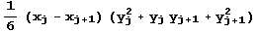 | 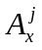
 | 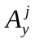
 | 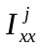
 | 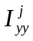
 | 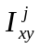

Table 2: Formulas for area and moment of inertias for a regular polygon
Element Formula | Property
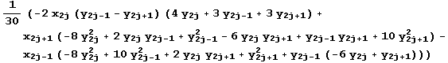
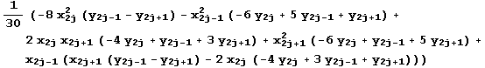

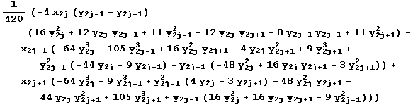

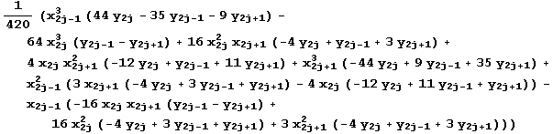
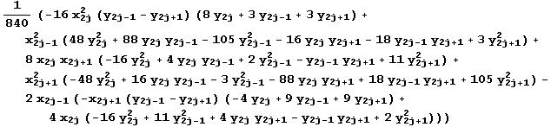

Table 3: Formulas for area and moment of inertias for a regular polygon
N | A/R² | Ixx/R⁴ = Iyy/R⁴
3 | 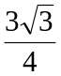 | 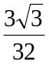
4 | 2 | 1/3
5 | 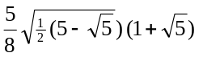 | 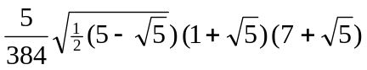
6 | 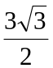 | 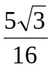
7 | 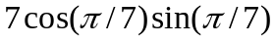 | 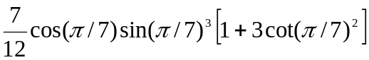
8 | 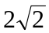 | 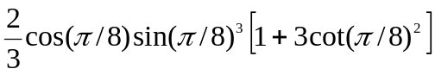
9 | 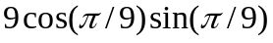 | 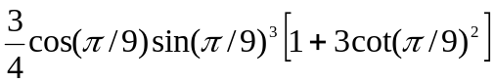
10 | 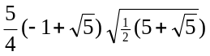 | 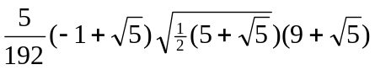
11 | 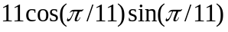 | 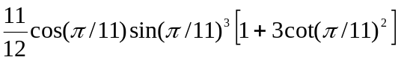
12 | 12 | 3

Table 4: Geometric & inertial properties for the shape in Example 2.
Property | N=6 | N=12 | N=18 | Exact
A | 2.5202 | 2.7805 | 2.7889 | 2.7908
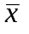 | -0.007184 | -0.09463 | -0.09601 | -0.09639
I_{xx} | 0.6702 | 0.7515 | 0.7215 | 0.7237
I_{yy} | 0.4335 | 0.5753 | 0.5509 | 0.5524

Table 5 Geometric & inertial properties for the shape in Example 3.
Property | N=12 | N=15 | N=20
A | 0.156905 | 0.174258 | 0.179203
 | 0.448153 | 0.44121 | 0.439323
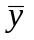 | 0.25714 | 0.251888 | 0.252817
I_{xx} | 0.0110718 | 0.012269 | 0.0129379
I_{yy} | 0.0396676 | 0.0441886 | 0.0450913
I_{xy} | 0.016662 | 0.0179857 | 0.0185271

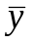
C
y

x

Figure 1: 2-D area with irregular interior and exterior boundaries

x_{j}(z=0)

y

{X_{j+1 ,} y_{j+1}} (z=1)

{X_{j ,} y_{j}} (z=0)

x

Figure 2: Discretization of interior and exterior boundaries

x
y

R
α

Figure 3: Regular Polygon

x
y
ψ
a
r

Figure 4: Circular section with a semicircular groove

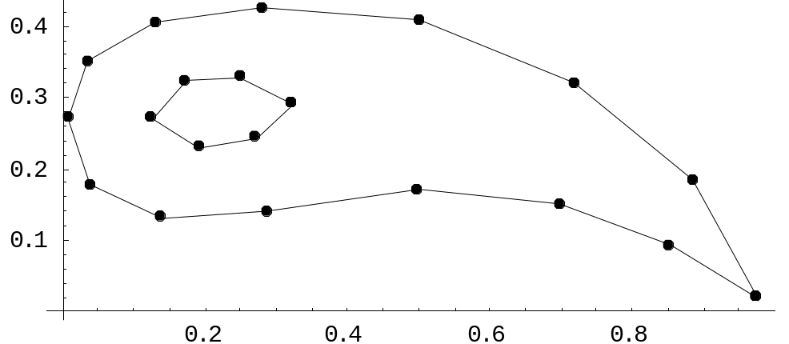
0.4
0.3
0.1
0.2
0.2
0.4
0.6
0.8

Figure 5: A turbine blade: (a) Geometry; (b) Discretization

